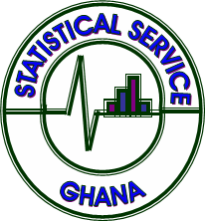

**Newsletter**

**Quarterly Gross Domestic Product (QGDP)**

**Third Quarter 2022**

**Quarter 2019**

**Ghana Statistical Service (GSS)**

***P.O. Box GP 1098, Accra***

***www.statsghana.gov.gh***

**Tel: +233-244-760080, +233-242-218079 Dec. 21, 2022**

**Contents**

1. Main points

2. Things you need to note about this release

3. Quarterly real GDP growth: July to September 2022

4. Real quarterly gross domestic product: July to September 2022

5. Nominal quarterly gross domestic product: July to September 2022

6. Sectoral shares of third quarter 2022 GDP

7. Seasonally Adjusted GDP

8. Appendix 1- Quarterly gross domestic product at current prices by economic activity and

respective sectoral distribution

9. Appendix 2- Quarterly value added and GDP at constant 2013 prices by economic

Activity

10. Appendix 3 - Seasonally adjusted quarterly value added and Gross Domestic Product

at Constant 2013 prices by economic activity

**Main points**

* Ghana provisional real Gross Domestic Product (GDP) in volume terms was estimated to have increased by 2.9% in quarter three (July to September) of 2022 compared to the same period in 2021.
* When seasonally adjusted, Ghana real GDP increased by 0.7% in quarter three (July to September) of 2022; 0.3 percentage points lower than what was recorded in quarter two (April to June) of 2022.
* The Mining & Quarrying, Information & Communication, Education, Crops, and Fishing sub-sectors were the main drivers of GDP growth for the third quarter of 2022.
* Main sub-sectors with more than 10 percentage expansion in quarter three of 2022 are:
  1. Information & Communication (18.4%)
  2. Mining & Quarrying (14.9%)
  3. Education, (10.2%)
* Nine sub-sectors contracted in quarter three of 2022. These are:
  1. Professional, Administrative & Support Service activities (-12.1%)
  2. Other Personal Service Activities (-8.6%)
  3. Manufacturing (-7.4%)
  4. Construction (-7.0%)
  5. Real Estate (-6.6%)
  6. Hotels & Restaurants (-6.4%)
  7. Trade (-2.4%)
  8. Electricity (-3.9%).
  9. Water (-3.0%)

**Things you need to note about this release**

Gross Domestic Product (GDP) growth is the main indicator of economic performance. There are three approaches used to measure GDP: the output approach, the expenditure approach, and the income approach.

This Statistical Release contains independently compiled quarterly estimates of the Gross Domestic Product (GDP) for the 3rd quarter of 2022 using the production approach. The estimates are based on the 2008 System of National Accounts (SNA), the International Standard Industrial Classification (Rev.4) published by the United Nations, and the Quarterly National Accounts Manual: Concepts, Data Sources and Compilation prepared by the International Monetary Fund (IMF). This means that the methodology, concepts, and classifications are in accordance with the guidelines and recommendations of an internationally agreed system of national accounts. The estimates of real GDP are expressed in terms of the base year, 2013. The Annual GDP estimates are derived independent of the quarterly estimates. Short-term indicators are used to estimate the quarterly GDP (see IMF’s Quarterly National Accounts Manual: Concepts, Data Sources and Compilation) and benchmarked to the annual GDP.

**Current or Nominal GDP** is the value of final goods and services evaluated at current quarter prices.

**Constant or Real GDP** is the value of final goods and services evaluated at base year prices. In Ghana, the base year is 2013. By using the prices from the base-year (or holding prices constant over time), we eliminate the impact of rising prices on GDP in order to get a measure of “Real” economic activity.

**Seasonal Adjustment**

The quarterly value added, and GDP estimates have been seasonally adjusted. Seasonal adjustment is the process of estimating and removing seasonal effects from time series to reveal non-seasonal features. This process is to provide a clearer view of short-term movements and trends and to allow early identification of turning points.

**Revision Policy**

While the majority of revisions are made to the four most recent quarters of the series, there is no restriction on when an estimate of the quarterly series for a given period can be revised. The main causes of revisions are as follows:

1. Incorporation of additional and improved data: Most revisions reflect the incorporation of a wider range of data. In particular, some data that were not available at the release date are incorporated through revisions into subsequent releases.
2. Reconciliation of quarterly and annual measures: The process of reconciling the quarterly measures with the annual measures can lead to further revisions. The quarterly measures of these series are based on a smaller range of data than the annual measures.
3. The rebased provisional quarterly GDP estimates may be revised further and finalized based on the availability of additional data. The next revision of the quarterly and annual GDP estimates will be done in April 2023.

**Related Publications**

Users may refer to other publications on GDP on the **GSS website: www.statsghana.gov.gh**

**Quarterly real GDP growth: July to September 2022**

Provisional real quarterly gross domestic product (QGDP) growth rate including Oil and Gas, is 2.9% (year on year) in the third quarter of 2022. In the same period of 2021, the growth was 6.5%.

GDP growth rate without oil and gas (Non-Oil GDP) for third quarter of 2022 is 3.6 % which compares to the same period in 2021 with a growth rate of 8.2%.

The Agriculture sector recorded the highest growth of 4.6%, followed by the Services sector with a growth of 3.9% and the Industry sector with a 0.9 percent growth rate.

**Figure1: Quarterly real GDP growth rate (2020Q3-2022Q3)**

**Real quarterly gross domestic product: July to September 2022**

The **GDP** (Including Oil & Gas) estimate at constant 2013 prices for the 3rd quarter of 2022 was **GH¢44,289.7 million** compared to **GH¢43,025.3 million** in the 3rd quarter of 2021.

The **Non-oil GDP** at constant 2013 prices for the 3rd quarter of 2022 was **GH¢41,586.5 million** compared to **GH¢40,156.7 million** in the 3rd quarter of 2021.

**Table1: Year-on-year growth rates in 3rd quarter of 2022**

|  |  |  |  |  |
| --- | --- | --- | --- | --- |
| **Sector** | **Expanding sub-sectors** |  | **Contracting sub-sectors** | |
| Agriculture  (4.6%) | Fishing  Livestock  Forestry & Logging  Crops and cocoa | 10.0%  5.8%  4.7%  4.0% |  |  |
| Industry  (0.9%) | Mining & Quarrying | 14.9% | Manufacturing  Construction  Electricity  Water Supply, Sewerage, Waste Management &  Remediation Activities | -7.4%  -7.0%  -3.9%    -3.0% |
| Services  (3.9%) | Information &  Communication  Education  Health & Social Work  Transport & Storage  Finance & Insurance  Public Administration &  Defence, Social Security | 18.4%  10.2%  8.1%  6.4%  5.1%    4.3% | Professional,  Administrative & Support  Other Personal Service  Activities  Real Estate  Hotel & Restaurants  Trade, Repair of Vehicle, Household Goods | -12.1%    -8.6%    -6.6%    -6.4%  -2.4% |

**Nominal quarterly gross domestic product: July to September 2022**

The GDP estimate at current prices in purchaser’s value[1] for the 3rd quarter of 2022 was **GH¢149,876.7 million** compared to **GH¢112,489.5 million** in the 3rd quarter of 2021.

The **Non-oil GDP** (GDP without Oil and Gas) estimate at current prices for the 3rd quarter of 2022 was **GH¢139,980.6 million** compared to **GH¢106,999.4 million** in the 3rd quarter of 2021.

**GDP sectoral shares**

The Services sector continue to be the largest sector of the Ghanaian economy in the second quarter of 2022 with a share of 44.4 percent of GDP at basic prices. The GDP share of Industry and Agriculture were 33.6 percent and 22.0 percent respectively.

**Figure 2: Sectoral distribution (%) of nominal GDP at basic prices**

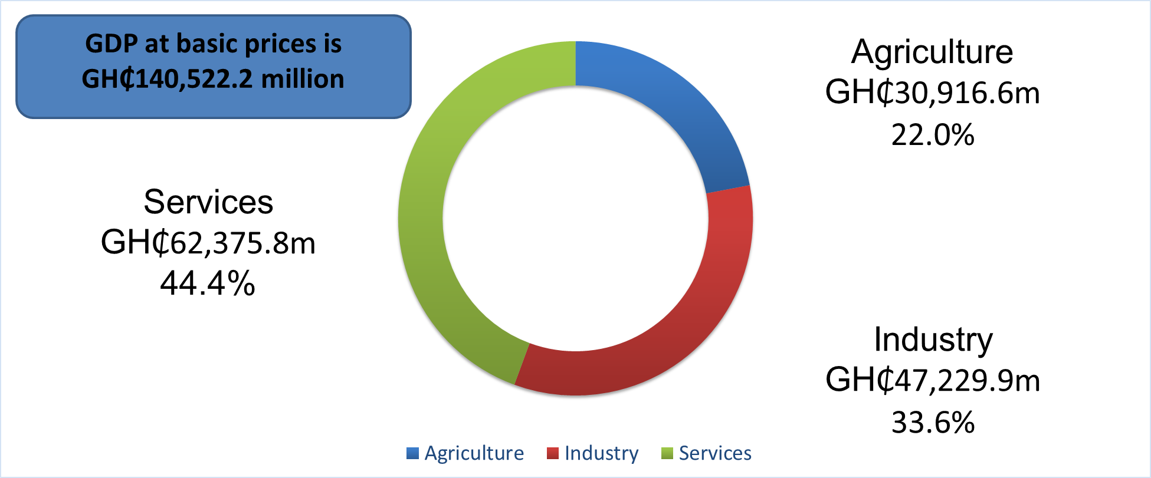

**Seasonally Adjusted GDP**

**The Provisional quarter-on-quarter[2] seasonally adjusted Real Gross Domestic Product (including Oil) growth rate for the 3rd quarter of 2022 was 0.7 percent.**

For the 3rd quarter of 2022, the quarter-on-quarter seasonally adjusted growth rates (see Table 2) were as follows:

* The Agriculture sector expanded by 1.0 percent in 3rd quarter 2022 compared to 0.9 percent in the 2nd quarter of 2022. The Fishing sub-sector increased by 1 percentage point from 1.7 percent in the 2nd Quarter 2022 to 2.7 percent in the 3rd quarter of 2022. The growth of Crops & Cocoa sub-sectors improved marginally to 0.9 percent from 0.8 percent in the 2nd quarter of 2022. The Livestock subsector declined to 1.1 percent from 1.2 percent recorded in the 2nd quarter of 2022. The Forestry and Logging sub-sector expanded by 1.1 percent in the 3rd quarterof 2022.
* Within the Industry sector which expanded by 0.2 percent (quarter on quarter), the Mining & Quarrying sub-sector expanded further from 1.5 percent in the 2nd quarter of 2022, to 3.6 percent in the 3rd quarter of 2022. Manufacturing sub-sector declined by 1.8 percent in the 3rd quarter of 2022 compared to an expansion of 1.2 percent in the 2nd quarter of 2022. There were contractions in the construction (-1.8%), Electricity (-1.0%) and Water Supply, Sewerage, Waste Management & Remediation Activities (-0.9%) sub-sectors in the 3rd quarter of 2022 compared the 2nd quarter of 2022.
* In the Services sector, Information & Communication sub-sector expanded by 4.0 percent in the 3rd quarter of 2022 compared to a growth of 2.6 percent in the 2nd quarter of 2022. Health & Social Work activities and Education recorded a growth rate of 2.2 and 2.8 percent in quarter three of 2022 from 3.3 and 3.1 percent respectively in quarter two of 2022.

Public Administration, Defense & Social Security recorded a marginal decline in growth from 2.0 percent in the 2nd quarter of 2022 to 1.2 percent in the 3rd quarter of 2022. Transport & Storage expanded by 1.6 percent in the 3rd quarter of 2022 compared to a growth of 0.4 percent in the 2nd quarter of 2022. Finance & Insurance maintained its 1.1 percent growth between quarters two and three of 2022.

There were however contractions in the remaining activities within the services sector

**Table 2: Quarter-on-quarter seasonally adjusted growth rates in 2022Q3**

|  |  |  |  |  |
| --- | --- | --- | --- | --- |
| **Sector** | **Expanding sub-sectors** |  | **Contracting sub-sectors** | |
| Agriculture  (1.0%) | Fishing  Livestock  Forestry & Logging  Crops and Cocoa | 2.7%  1.1%  1.1%  0.9% |  |  |
| Industry (0.2%) | Mining & Quarrying | 3.6% | Manufacturing  Construction    Electricity  Water Supply, Sewerage, Waste Management & Remediation Activities | -1.8%  -1.8%  -1.0%  -0.9% |
| Services (1.0%) | Information & Communication  Education  Health & Social Work  Transport and Storage  Public Administration &  Defence, Social Security  Finance & Insurance | 4.0%  2.8%  2.2%  1.6%  1.2%  1.1% | Professional,  Administrative & Support  Real Estate  Other Personal Service Activities  Hotels & Restaurants  Trade; Repair of Vehicles, Household Goods | -3.9%  -3.0%  -2.2%  -1.2%  -0.5% |

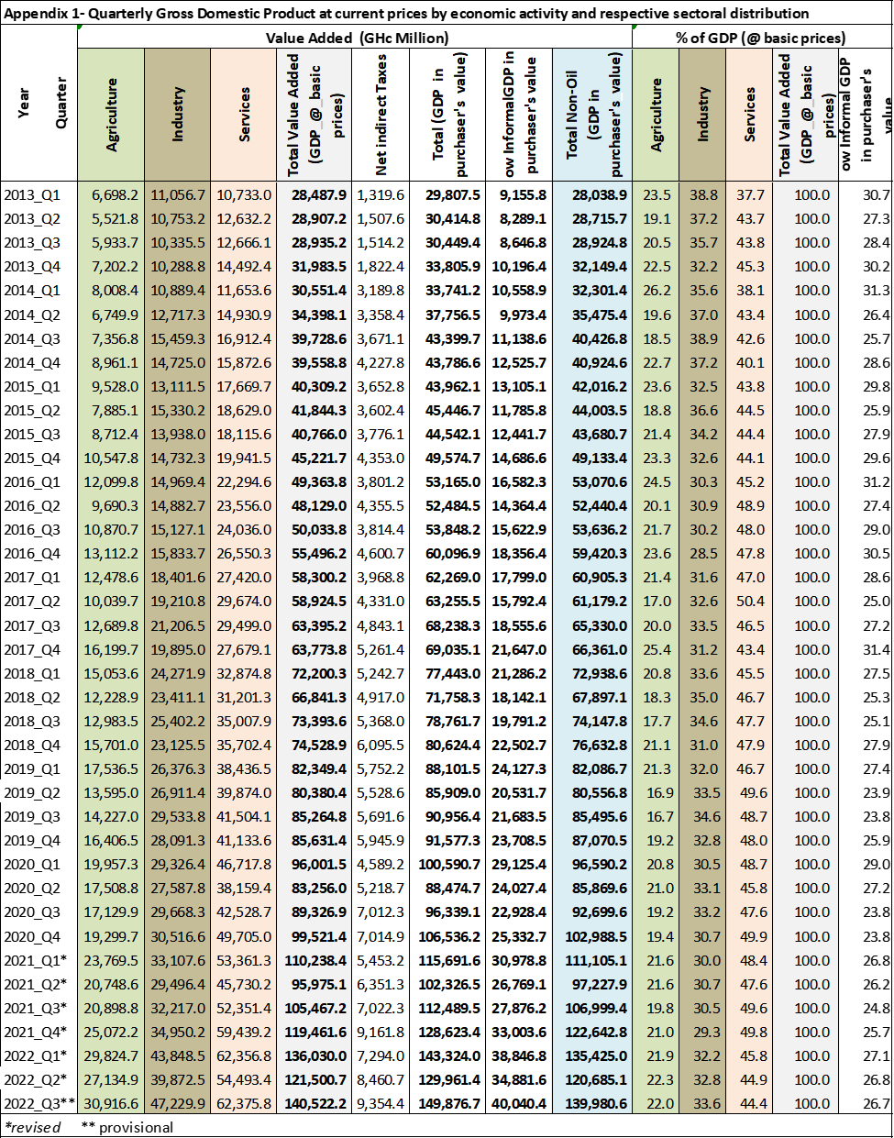





1.
2. Quarter-on-quarter GDP estimates provide a short term (within three months) picture of current economic developments. Estimates are influenced by seasonal patterns that are caused by economic behavior or recurrent exogenous factors such as weather patterns, holidays, religious events, festive seasons, etc.